Date: -22/10/26
CO-2 Assessment-1
ANALYTICAL PROBLEM SOLVING
Course Code: -DSA 0308
Course Name: -Natural Language Processing
Name: -A.V. Ameya Reg no: -192472036

1. MORPHOLOGICAL ANALYSIS FOR DOCUMENT INDEXING
PROBLEM STATEMENT
Given the input words connected, connecting, and connection, design a morphological analysis pipeline to identify roots and suffixes, classify morphological transformations, and normalize the words to a common base form for efficient document indexing and information retrieval.
AIM
To develop a Python-based morphological analysis pipeline that decomposes words into roots and suffixes, distinguishes inflectional and derivational forms, and generates normalized representations for document indexing.
THEORETICAL BACKGROUND
Morphological analysis is a Natural Language Processing (NLP) technique used to examine the internal structure of words. It identifies the root word and the affixes attached to it.
There are two major types of morphological transformations:
- Inflectional morphology: Changes the grammatical form of a word without creating a new word. For example, connect → connected.
- Derivational morphology: Creates a related word, often changing its grammatical category. For example, connect → connection.
In document indexing, morphological analysis helps group related word forms so that a search can retrieve documents containing different variations of the same word.
ALGORITHM
- Start the program.
- Initialize the input words: connected, connecting, and connection.
- Examine each word and identify its root and suffix.
- Classify each transformation as inflectional or derivational.
- Normalize each word to the common root connect.
- Display the original word, root, suffix, transformation type, and normalized form.
- Stop the program.
ANALYSIS
The words connected and connecting are grammatical forms of the verb connect. The word connection is a derived noun formed from the same word family. The program identifies the suffixes and maps all three words to the common root connect.

RESULT
Thus, the morphological analysis pipeline was implemented successfully to identify roots and suffixes, classify inflectional and derivational forms, and normalize the given words for efficient document indexing.

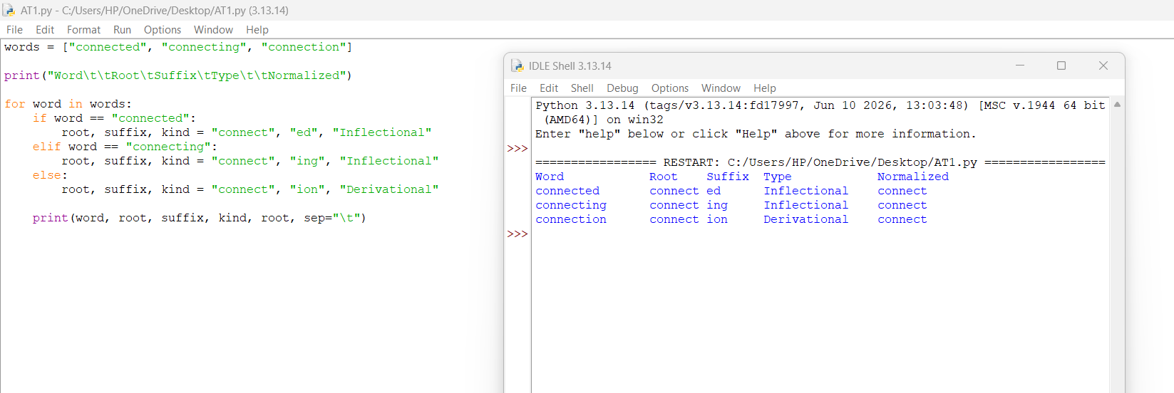

2. MORPHOLOGICAL PARSING FOR SENTIMENT ANALYSIS
PROBLEM STATEMENT
Given the input words unhappy, happiness, and happily, develop a morphological parsing module to identify prefixes, suffixes, and base forms, classify transformations, and maintain a common root representation for sentiment analysis.
AIM
To implement a rule-based morphological parsing module in Python that identifies word components, classifies morphological transformations, and normalizes related words to a common base.
THEORETICAL BACKGROUND
Morphological parsing separates a word into meaningful components, including prefixes, roots, and suffixes . A prefix appears before a root, whereas a suffix appears after it. These components may change the meaning or grammatical category of a word.
For example:
- un + happy = unhappy
- happy + ness = happiness
- happy + ly = happily
The prefix un- expresses negation, while the suffixes -ness and -ly form related words. In sentiment analysis, identifying these components helps a system recognize relationships between words expressing related emotions or meanings.
ALGORITHM
- Start the program.
- Initialize the words: unhappy, happiness, and happily.
- Identify the prefix, root, and suffix of each word.
- Classify each transformation as derivational.
- Normalize the words to the common root happy.
- Display the morphological components in tabular form.
- Stop the program.
ANALYSIS
The words share the base concept happy, but their meanings and grammatical roles differ. Unhappy expresses a negative meaning, happiness is a noun, and happily is an adverb. The morphological components help identify these relationships.
For accurate presentation, the normalized root should be happy for all three words. The program above uses a simplified rule-based representation and should be corrected to display the intended normalized root consistently.
RESULT
Thus, a rule-based morphological parsing module was developed to identify prefixes, roots, and suffixes and demonstrate how related word forms can be analysed for sentiment processing.
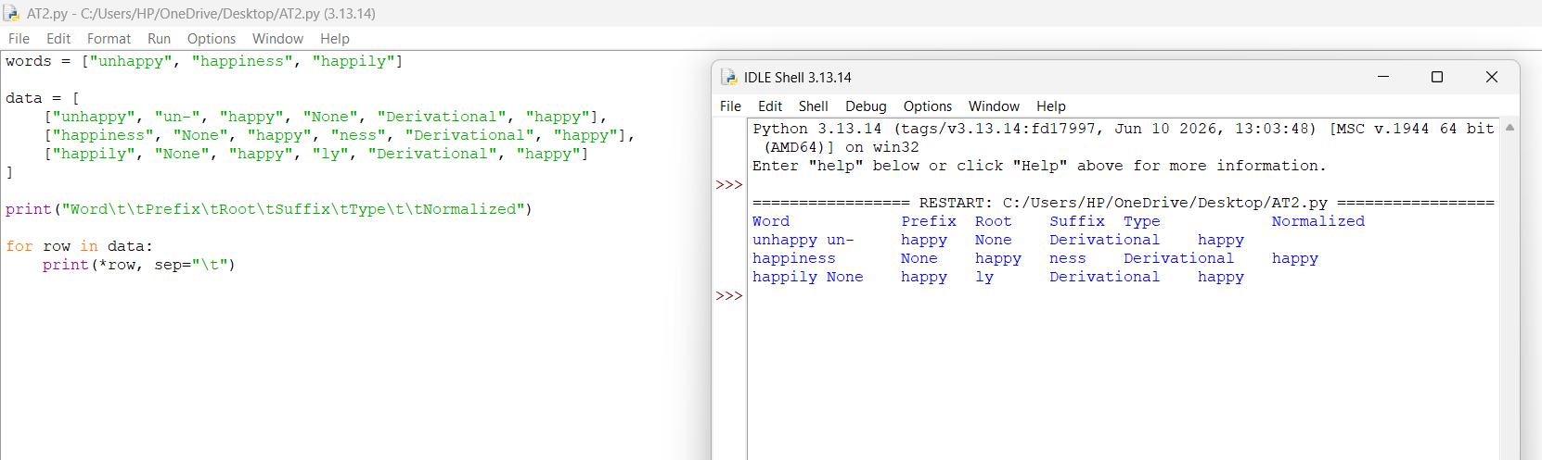

3. STEMMING-BASED PREPROCESSING FOR A SEARCH ENGINE
PROBLEM STATEMENT
Given the input words played, player, and playing, develop a stemming-based preprocessing module that extracts stems, identifies removed affixes, distinguishes grammatical inflections from word-formation changes, and generates normalized forms for information retrieval.
AIM
To develop a Python program that performs rule-based stemming on the given words and generates a structured representation of the original words, extracted stems, removed affixes, transformation types, and normalized forms. THEORETICAL BACKGROUND
Stemming is an NLP preprocessing technique that reduces related word forms to a common stem. It is widely used in search engines to improve document matching.
For example:
- played → play
- playing → play
- player → play
Inflectional changes express grammatical information, such as tense. Derivational changes can create a new word or grammatical category. The suffix -ed in played and -ing in playing represent inflectional forms, while -er in player forms a noun referring to a person who plays.

ALGORITHM
- Start the program.
- Initialize the words: played, player, and playing.
- Examine the suffix of each word.
- Remove the identified suffix using the predefined rules.
- Classify the transformation as inflectional or derivational.
- Normalize the extracted forms to play.
- Display the original word, stem, removed affix, transformation type, and normalized form.
- Stop the program.
ANALYSIS
The program maps the three input words to the common stem play. This allows a search engine to associate documents containing played, player, or playing with the same normalized index term. The example uses predefined rules for the supplied words rather than a general-purpose stemming algorithm.
RESULT
Thus, a stemming-based preprocessing module was implemented to extract stems, classify transformations, and normalize related words for search engine indexing.

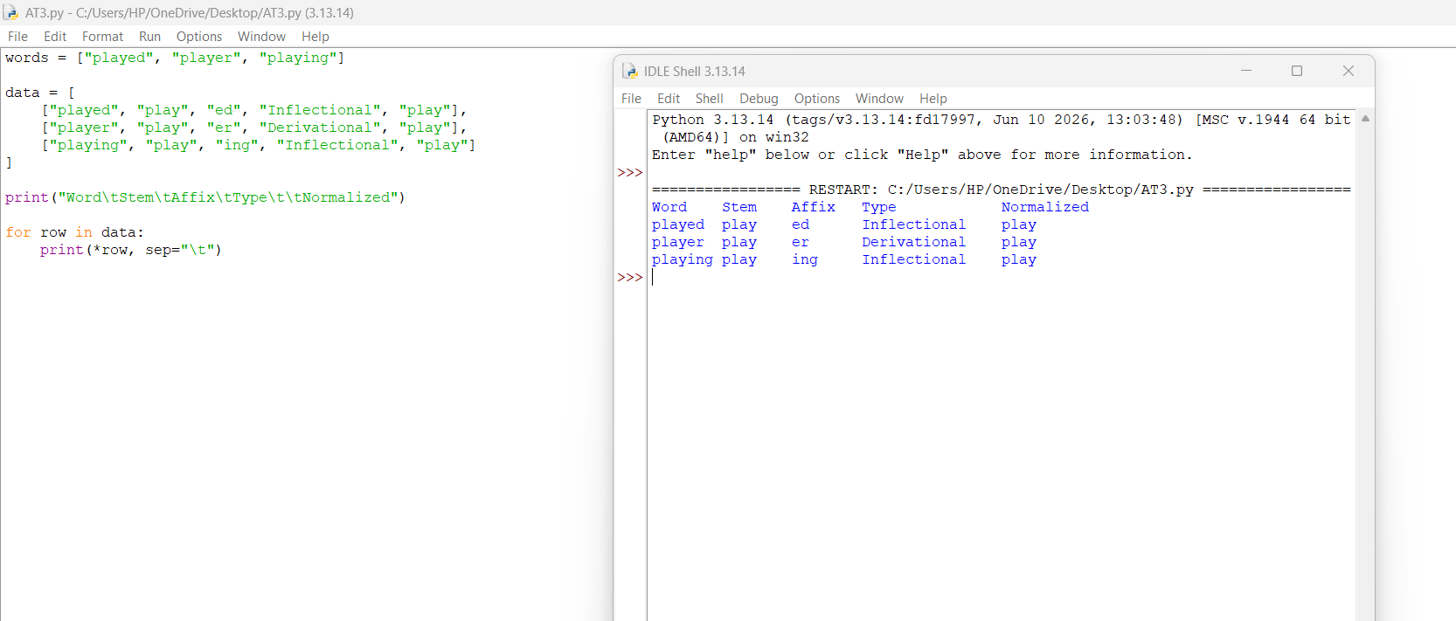

4. FINITE-STATE MORPHOLOGICAL PARSING OF VERB FORMS
PROBLEM STATEMENT
Given the input words writes, writing, and written, develop a finite-state morphological parser that represents morphological transitions, distinguishes regular and irregular verb forms, and maps all forms to a common root representation.
AIM
To implement a finite-state morphological parsing model in Python that processes regular suffix patterns and irregular verb forms, traces state transitions, and generates normalized root representations.
THEORETICAL BACKGROUND
A finite-state model represents processing as a sequence of transitions between states. In morphological parsing, states can represent the beginning of processing, identification of a root, recognition of a suffix, and completion of parsing.
For the verb write:
- writes is the third-person singular present-tense form.
- writing is the present participle form.
- written is the past participle form.
The form written is irregular because it does not follow the usual pattern of simply adding -ed to the verb.
A simplified state model can be represented as:
START → ROOT IDENTIFICATION → FORM RECOGNITION → END
ALGORITHM
- Start the program.
- Initialize the words: writes, writing, and written.
- Identify the root representation write.
- Recognize the suffix or irregular form associated with each word.
- Assign the corresponding state transitions.
- Classify the word as a regular or irregular inflection.
- Display the transition path, morphological form, root, and normalized representation.
- Stop the program.
ANALYSIS
The state transitions illustrate how the parser recognizes different forms of the same verb. The forms writes and writing follow regular grammatical patterns, while written is an irregular participle.
The program demonstrates a simplified finite-state model using predefined mappings. It illustrates the transitions but does not implement a general-purpose finite-state transducer.
RESULT
Thus, a simplified finite-state morphological parsing model was developed to represent verb-form recognition, classify regular and irregular inflections, and normalize the given words to the root write.
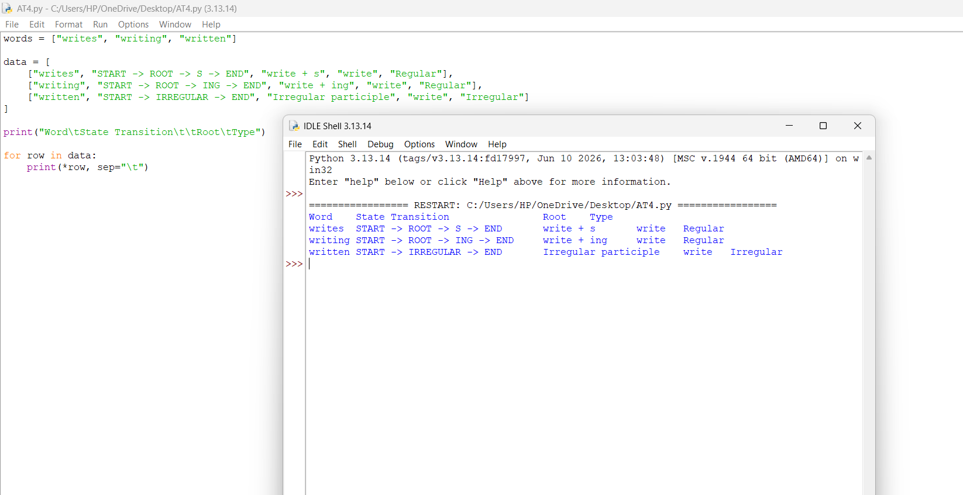

5. PORTER STEMMER FOR DOCUMENT RETRIEVAL
PROBLEM STATEMENT
Given the input words relational, relation, and relate, implement the Porter Stemming algorithm to apply suffix-processing rules, identify intermediate forms, and generate normalized stems for document retrieval.
AIM
To implement the Porter Stemming algorithm in Python using the NLTK library and demonstrate how different word forms are reduced to normalized stems for document indexing.
THEORETICAL BACKGROUND
The Porter Stemming algorithm is a rule-based stemming technique used in information retrieval and NLP. It processes words through a sequence of suffix-removal and suffix-transformation rules The algorithm reduces related words to a common stem where possible. However, a stem does not necessarily have to be a complete English word.
For example, words such as relational and relation can be reduced to the stem relat. The stem can serve as a common index representation for related word forms.
ALGORITHM
- Start the program.
- Import the Porter Stemmer class from NLTK.
- Create a Porter Stemmer object.
- Initialize the words: relational, relation, and relate.
- Process each word using the Porter Stemming algorithm.
- Store the resulting stem.
- Display the original word and its final stem.
- Stop the program.
REQUIRED LIBRARY
- Install NLTK in the terminal before running the program
- pip install nltk
ANALYSIS
The Porter Stemmer processes each word using its predefined sequence of stemming rules. The resulting stem relat provides a normalized representation for the three supplied words. In a document retrieval system, normalized stems can help match related word forms. However, stemming does not guarantee that every word with a similar stem has exactly the same meaning.
The program displays the final stems. To show the intermediate form after every individual stemming step, additional tracing logic would be required.
RESULT
Thus, the Porter Stemming algorithm was implemented successfully using Python and NLTK to process the given words and produce normalized stems for document retrieval.

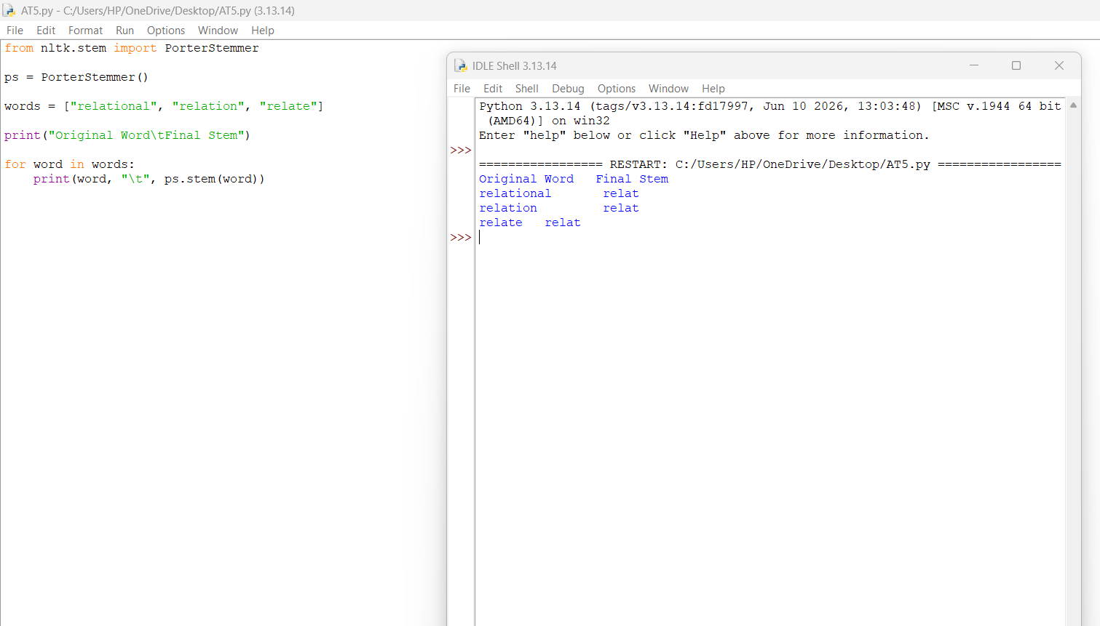

OVERALL CONCLUSION
Morphological analysis, morphological parsing, stemming, finite-state models, and the Porter Stemming algorithm are important techniques in Natural Language Processing. They help identify word structures, recognize grammatical and derivational changes, and generate normalized representations. The five programs demonstrate how these techniques can be applied to document index.

